|  |  |
| --- | --- |
| Date | 01 November 2022 |
| Team ID | PNT2022TMID17702 |
| Project Name | Industry specific intelligent fire  management system |

SPRINT - 1

WOKWI WEB URL:

<https://wokwi.com/projects/347953543893746258>

**SNAPSHOTS OF SIMULATION:**

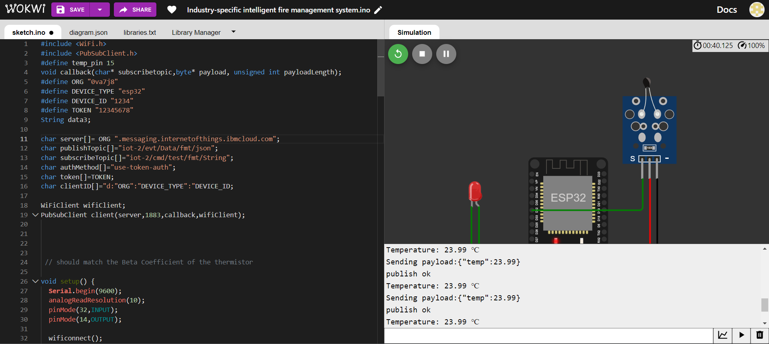

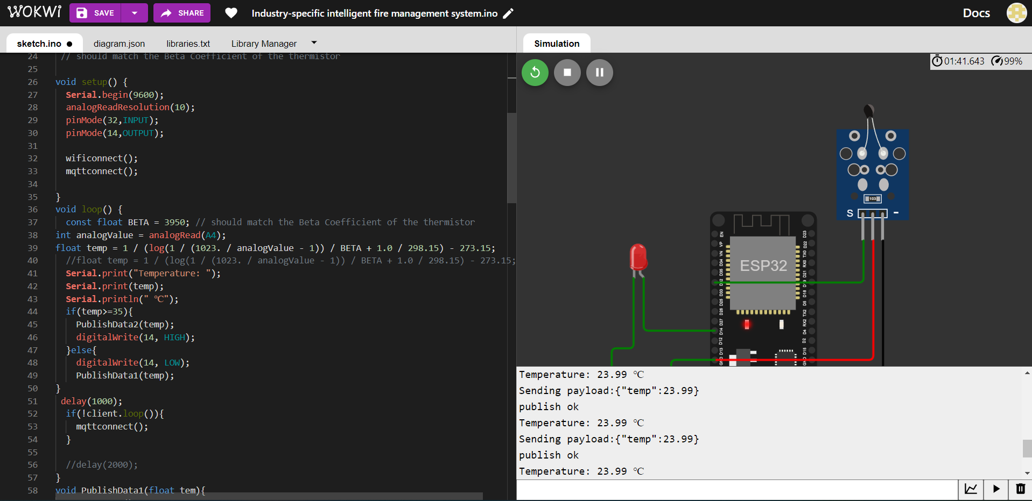

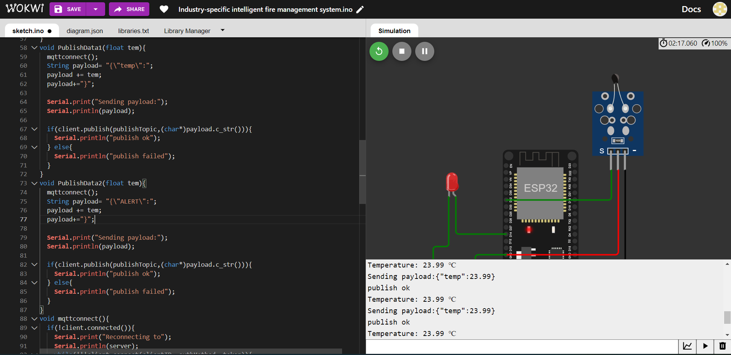

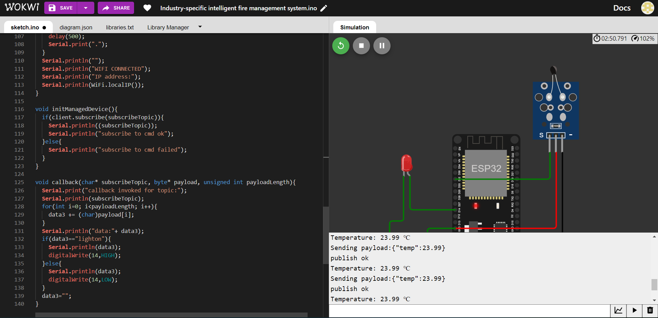

**Images of IBM Watson Iot Platform Recent events:**

